Specific Area: Maths - NUMBER
0-2 years | 2-3 years | 3-4 years | Reception | ELG
-Combine objects like stacking blocks and cups.  -Put objects inside others and take them out again  -Combine objects like stacking blocks and cups. -Put objects inside others and take them out again  -Compare amounts, saying ‘lots’, ‘more’ or ‘same’.  -Develop counting-like behaviour, such as making sounds, pointing or saying some numbers in sequence.  -Climb and squeeze themselves into different types of spaces.  -Build with a range of resources.  -Begin to compare sizes, weights etc. using gesture and language – big, small | -Compare amounts, saying ‘lots’, ‘more’ or ‘same’.  - saying some numbers in sequence.  -Count in everyday contexts, sometimes skipping numbers – ‘1-2-3-5’  - Complete inset puzzles  Compare sizes, weights etc. using gesture and language - ‘bigger/little/smaller’, ‘high/low’, ‘tall’, ‘heavy’  Notice patterns and arrange things in patterns.  -Begin to recite numbers past 5.  -Begin to link numbers and amounts | -Develop fast recognition of up to 3 objects, without counting them individually.  -Recite numbers past 5.  -1 to correspondence to 5.  -Know that the last number reached when counting a small set of objects tells you how many there are in total -Show ‘finger numbers’ to 5.  -Link numerals and amounts  -Experiment with their own symbols and marks as well as numerals.  -Solve real world mathematical problems to 5  -Compare quantities using language: ‘more/‘fewer than’  -Understand position through words, no pointing.  -Describe a familiar route and discuss using words like ‘in front of’ and ‘behind’  -Make comparisons between objects relating to size, length, weight and capacity.  -Select shapes appropriately: flat surfaces for building, etc. -Combine shapes to make new ones – an arch,  -Talk about and identify the patterns around like stripes.  -informal language- ‘pointy’  -Extend/make ABAB patterns  & correct an error.  -Begin to describe a sequence of events, using words such as ‘first’, ‘then...’ | Subitise  Link the number symbol (numeral) with its cardinal number value  Count beyond ten.  Compare numbers  Understand the ‘one more than/one less than’ relationship between consecutive numbers.  Explore the composition of numbers to 10  Automatically recall number bonds for numbers 0–5 and some to 10  Select, rotate and manipulate shapes to develop spatial reasoning skills  Compose and decompose shapes so that children recognise a shape can have other shapes within it, just as numbers can  Continue, copy and create repeating patterns.  Compare length, weight and capacity. | Mathematics  ELG: Number  Children at the expected level of development will:  - Have a deep understanding of number to 10, including the composition of each number; 14  - Subitise (recognise quantities without counting) up to 5;  - Automatically recall (without reference to rhymes, counting or other aids) number bonds up to 5 (including subtraction facts) and some number bonds to 10, including double facts.  ELG: Numerical Patterns  Children at the expected level of development will:  - Verbally count beyond 20, recognising the pattern of the counting system;  - Compare quantities up to 10 in different contexts, recognising when one quantity is greater than, less than or the same as the other quantity;  - Explore and represent patterns within numbers up to 10, including evens and odds, double facts and how quantities can be distributed equally.  ELG: Shape, Shape and measure  Children at the expected level of development will:  -Recognise 2d shapes in different ways  -create and continue repeated patterns  -Compare weight, length and capacity  -

Federation Reception Meeting requirements for Number
Reception meeting statements ‘Year 1 ready’
- Beginning to use number bonds to 10 to solve problems.  - To record simple addition and subtraction sums as number sentences with increasing confidence.  - Solve practical problems that involve combining groups of 2,5,10 and sharing into equal groups  - Doubling, halving and sharing within practical contexts.  - To begin to read and record 2 digit numbers, with accuracy. |  | 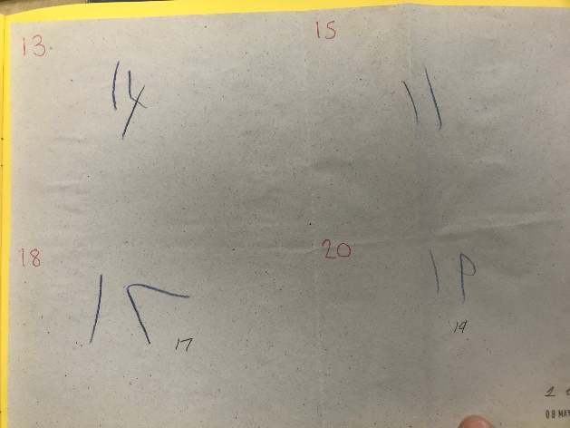  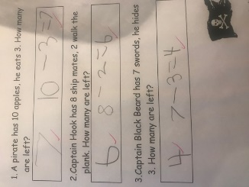
If children are advancing, they should demonstrate:  - Children estimate a number of objects and check quantities by then counting  - Solve practical problems that involve combining groups of 2,5,10 and sharing into equal groups  - Children estimate, measure, weigh, compare and order objects.  And also…  - Doubling, halving and sharing within practical contexts.  - Talk about properties of shape confidently.  - Discuss/use positional language  - Have an awareness of time. |  | Children begin to use maths in everyday situations – we have one pupil off so there’s 19  Children can mentally see patterns in number at age related expectation  Children can select maths equipment to assist their learning

