Year 6 - Study Books
Below are some suggested books that you may wish to purchase to support your child on their journey through Year 6. These can be purchased online (we have hyperlinked the books below to a large online retailer), or at many high street book stores.
Many thanks for your continued support,
The Year 6 Team.
Maths | SPaG | Reading
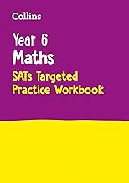 | 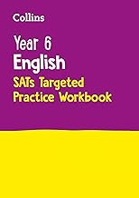
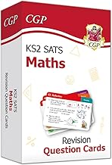 | 