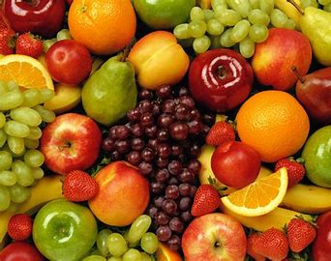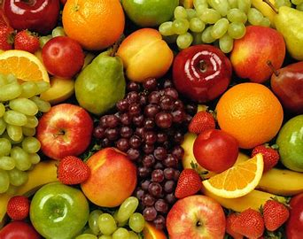

WEEK ONE MENU

|  |  |  |  |
| --- | --- | --- | --- |
|  | OPTION 1 | OPTION 2 | SUBS |
| Monday | Vegetarian Sausage roll with Creamed Potatoes | Pasta Italienne | Ham  Cheese  Tuna |
| Tuesday | All Day Breakfast | Plant Friendly All Day Breakfast | Ham  Cheese  Tuna |
| Wednesday | Beef Lasagne & Garlic Bread | Jacket Potato with various fillings | Ham  Cheese  Tuna |
| Thursday | Chicken Slider in a bun with potato wedges | Golden Toastie | Ham  Cheese  Tuna |
| Friday | Fish Fingers & Chips | Vegetable & lentil Curry | Ham  Cheese  Tuna |

**AVAILABLE EVERYDAY**

Fresh cooked vegetables or salad.

A different dessert everyday with fresh fruit or yoghurt.

Bread basket.

Milk and water.

WEEK TWO MENU

WEEK TWO MENU

|  |  |  |  |
| --- | --- | --- | --- |
|  | OPTION 1 | OPTION 2 | SUBS |
| Monday | BBQ Pulled Pork Wrap with savoury rice | Tuna Pasta Bake | Ham  Cheese  Tuna |
| Tuesday | Homemade Pizza | Pasta Carbonara | Ham  Cheese  Tuna |
| Wednesday | Roast Chicken Dinner | Roast Quorn Dinner | Ham  Cheese  Tuna |
| Thursday | Chicken & Tomato Pasta Bake | Jacket Potato with Various Fillings | Ham  Cheese  Tuna |
| Friday | Breaded Fish Star & Chips | Vegetable Frittata | Ham  Cheese  Tuna |

**AVAILABLE EVERYDAY**

Fresh cooked vegetables or salad.

A different dessert everyday with fresh fruit or yoghurt.

Bread basket.

Milk and water.