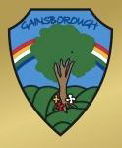
Gainsborough Primary and Nursery School
Curriculum Brochure for Parents and Carers
English  Key vocabulary: noun, noun phrase, adjective, verb, adverb, punctuation, statement, question, command, tense (past and present)  What pupils will learn:  In English this year, through our journey of some exciting stories we shall be visiting the sea. The children will look at features of a sea scape, do some descriptive writing and write about some of the wonderful characters they will meet along the way.  History  Key vocabulary: past, present, historical, heroine, rescue, museum  What pupils will learn:  I know about the lives of significant individuals who have contributed to national achievements.  In history we shall be learning about Grace Darling and her bravery at sea. We shall also look at her contribution towards the establishment of the RNLI.  Geography  Key vocabulary: England, Northern Ireland, Wales, Scotland, United Kingdom, land, sea, map, globe, oceans, countries, capital cities, London, Belfast, Cardiff, Edinburgh  What pupils will learn:  I know the countries of the UK.  I know the names of the capital cities of the UK.  I know the names of the seas surrounding the UK  In geography this term, the children will be learning about the UK. Through our stories in English and our work on Grace Darling in history, we shall be exploring the areas of land and sea that make the UK.  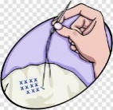  Design Technology -Sewing a pouch  Key vocabulary: needle  running stitch  sew  template  thread  What pupils will learn:  Sew a running stitch with regular-sized stitches and  understand that both ends must be knotted.  Prepare and cut fabric to make a pouch from a  template.  Use a running stitch to join the two pieces of fabric  together.  Decorate their pouch using the materials provided.  Art  Key vocabulary: painting, tone, shades, techniques and tints.  What pupils will learn:  I know how to mix tones and shades  I know how to mix secondary colours.  In art the children will explore tones and tints but adding black and white to blue to makes a seascape. They shall also be looking at how to mix primary colours to make secondary colours.  RE  Key vocabulary: Jesus, God, creations, special, Christian  What pupils will learn:  I know why Jesus is special to Christians.  In RE the children will explore lots of different ways in which Jesus is special to Christians. They shall also be looking at what makes them special and thinking about those people who are special to them and why. | Year 2  Autumn Term  Making a Splash!  Focus texts:  Storm Whale – Benji Davies  Storm Whale in Winter – Benji Davies  Grace Darling -Anita Ganeri  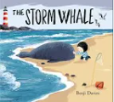  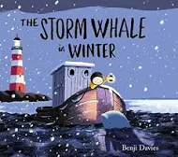  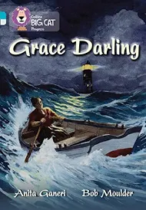  PSHE including well-being and mental health  Key vocabulary: nervous, excited, cross, angry, happy, right, wrong  What pupils will learn:  To know the school rules and values.  To understand that families should offer love and support.  To know families may be made up of different people.  I will consider friends’ thoughts and feelings.  I understand that situations happen in friendships and an adult can help to resolve them when needed.  PE- Wednesday – Dance/Throwing and catching  Key vocabulary: dance, twist, turn, leap  What pupils will learn:  I can perform dances using simple movement patterns.  I can extend my throwing and catching skills independently and with a partner.  Please ensure children have school PE kit in school at all times and all items are labelled.  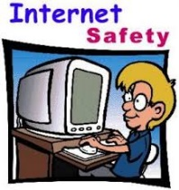  Computing  Key vocabulary: safe, search, internet, rules for online safety,  What pupils will learn:  I know how to search safely and effectively for information on the internet.  I can use the search facility to refine searches on Purple Mash by year group and subject.  I know that Email is a form of digital communication.  I can explain what a digital footprint is. | Maths  Key vocabulary: Addition, subtraction, take away, minus, more then, less than, sequence, order, tens, ones, compare, digit, subtract, total, array, times tables  What pupils will learn:  In maths this term the pupils will continue to work on all four mathematical operations (addition, subtraction, multiplication and division).  They will also learn about place value, more and less, greater and less than and money.  Science  Key vocabulary: materials, wood, plastic, metal, paper, cardboard, glass, brick, use,  suitability, compare, twist, bend, stretch, squash, push, pull, shape, flexible  What pupils will learn:  I know the names of everyday materials.  I know each material can be used in different ways.  I know some materials are not suitable for jobs and why.  I know some materials can have their shapes changed by twisting, squashing, bending and stretching them.  In science this term we shall be learning about materials. Children will be exploring different materials and their uses. They will also be looking at making a waterproof coat for a character in one of our stories.  Music  Key vocabulary: tempo, dynamics, timbre, percussion, rhythm  What pupils will learn:  I can listen to and recognise instrumentation.  I can recognise and understand timbre changes in the music I listen to  I can copy longer rhythmic patterns on untuned percussion instruments keeping a steady pulse.  I can successfully combine and layer several instrumental and vocal patterns within a given structure.  I can use my voice expressively when singing, including the use of basic dynamics.  I can sing short songs from memory, with melodic and rhythmic accuracy.  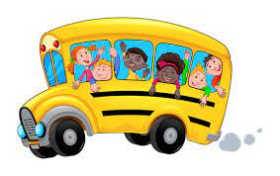  Educational Visits  Autumn 1:  21st October  Crewe memorial in the heart of the town- history and geography field trip  No cost to parents but packed lunch and suitable clothing and shoes will be required.  Autumn 2:  10th December – Aladdin theatre trip  Ticket cost TBC  Theatre visit to school - free

