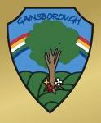
Gainsborough Primary and Nursery School
Curriculum Brochure for Parents and Carers
Communication and language  Key learning: Good sitting, listening ears, taking turns talking, joining in with stories and rhymes. Following instructions, asking for help or assistance, using clear pronunciation of words, speaking in full sentences.  What pupils will learn:  This area of learning is used to assess children’s ability to speak, pay attention, listen and understand. This is done in a variety of ways: listening to stories, developing their own narratives to share with others, small group activities to emphasise the importance of listening and taking turns to speak.  I can respond to simple instructions  I can listen to others and take turns in conversation  I can join in with singing songs and rhymes  I can ask for help when I need it  I can listen to stories supported by pictures and props  I can join in with telling familiar stories  I am beginning to show feelings and emotions  I can pronounce words with multiple syllables | Nursery  Summer 1  Summer Time  This term we will be doing a bug hunt at Queens park.  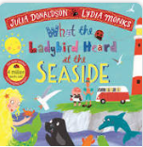  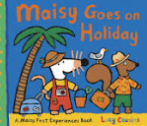  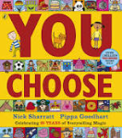  Summer 2  Traditional Tales  This term we will be visiting Glebe farm.  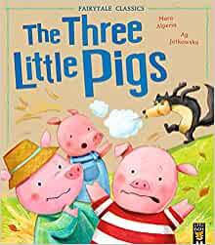  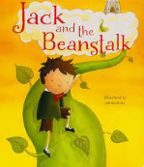  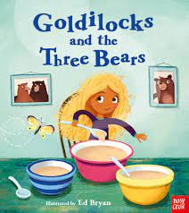  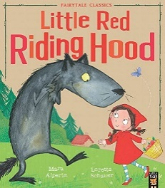 | Literacy  Key learning: Nursery rhymes, books, pictures, print, pages, holding a pen correctly, drawing circles and lines, reading our names, writing our names, recognising letters of the alphabet.  What pupils will learn:  This area of learning focuses on early mark making and writing. At this stage children are learning to hold a pen correctly and draw circles and lines, as well as begin to write their own names. It encourages children to talk about and share books and begin to recognise key words and logos.  I have some favourite rhymes and songs  I am starting to makes marks  I can tell you about the different marks I make  I can draw lines and circles  I am starting to be interested in books  I can tell simple stories using the pictures in books  I can read and write my name  I can recognise some letters of the alphabet
Personal, social and emotional development (PSED)  Key learning: Share, taking turns, helping, caring, play alongside and with others, show empathy and pride.  What pupils will learn:  This area of learning supports children to make relationships with their peers and other adults. It enables children to understand and talk about their feelings, develop independence and confidence, helps them to feel valued and gives them a sense of self-worth.  I am beginning to make friends  I can communicate my likes, dislikes and interests.  I am starting to follow simple routines  I am beginning to join in with other children’s play  I am proud of my achievements  I am kind and caring towards others  I am beginning to ask questions  I can ask for help |  | Understanding the World (UW)  Key learning: growing plants and flowers, watching the changes, caring for plants, using technology  What pupils will learn:  This area of learning focuses on how children make sense of their world and their community, by creating opportunities for them to explore, observe and find out about people, places, the environment and technology. Children will learn about planting and growing flowers and vegetables.  I can make up stories of events as I play  I enjoying exploring in the outdoor area  I can operate a simple computer programme or game  I can draw pictures using a computer programme  I can talk about routines and traditions in my home  I can talk about how flowers and vegetables grow  I can use a device to take a photograph
Maths  Key learning: to know numbers to 10, to begin to know numbers beyond 10, read and write numbers to 5, name shapes, order items by size, use positional language, match numeral to quantity.  What pupils will learn:  This area of learning enables children to learn number names through counting and joining in with rhymes and songs. Children will have the opportunities to explore, sort, compare and count. This supports them to be creative, critical thinkers and problem solvers.  I can say some number names in order  I can sing some number songs and rhymes  I can name 2D shapes  I can use words such as ‘big’ and ‘little’ to describe things  I can order items by size  I am starting to count to 10  I am beginning to count beyond 10  I can use positional language | Expressive Art and Design (EAD)  Key learning: representing things in picture form, playing role play and imaginative games, making music and beginning to move in time to music  What pupils will learn:  This area of learning is used to develop a child’s imagination, creativity and skill to use media and materials. This is done in a variety of ways which include: singing, dancing, making music, playing with colour and texture and design  I can join in with my favourite songs and rhymes  I can explore the different sounds I can make using musical instruments  I can make movement to music  I can draw pictures of things that are important to me  I can explore what happens when I use different craft techniques | Physical development (PD)  Key learning: Wash and dry hands, joining in with routines, running and negotiating space, holding a pen, balancing on one-foot, physical movements  What pupils will learn:  This area of learning is used to develop a child’s movement and handling of objects. They are learning how to independently change their own clothing, understand their own body, health and levels of self-care. They are building their physical skills.  I can run while negotiating space and obstacles  I can balance on one foot  I can kick a ball  I can wash and dry my own hands  I can use the toilet on my own  I can put on and take off my own shoes  I can put on and take off my own coat  I can do buttons and poppers

