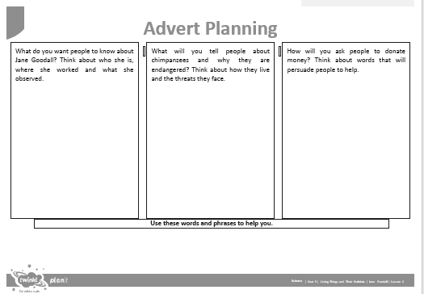

**Word bank:** British scientist world expert Gombe Tanzania Africa names personalities family chimpanzees species extinct endangered forest meat pets lifecyle