All about me:

This is a picture of me
My name is: ............................................................................................................
My age is: ................................................................................................................
MY CIRCUIT BOOK
Warm Up!
When I perform my circuit I understand the importance of doing a warm-up first.
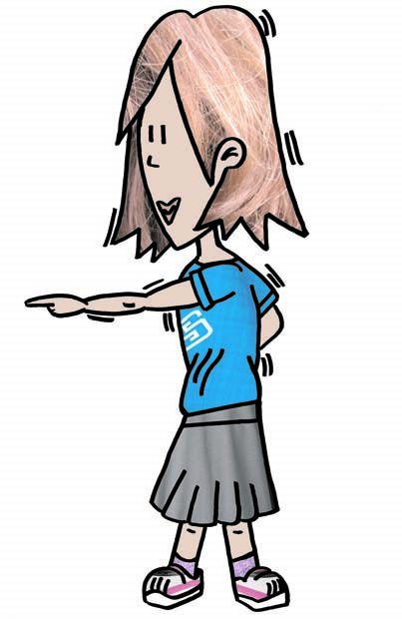
Put the missing words in the correct sentence:
Muscles Faster Prepares Flexible
A warm-up _____________ my body for exercise.
My heart beats _____________ after I have performed a warm – up.
My heart will help to pump blood into my _____________
When my muscles become warm they are more _____________
The Beanbag-spe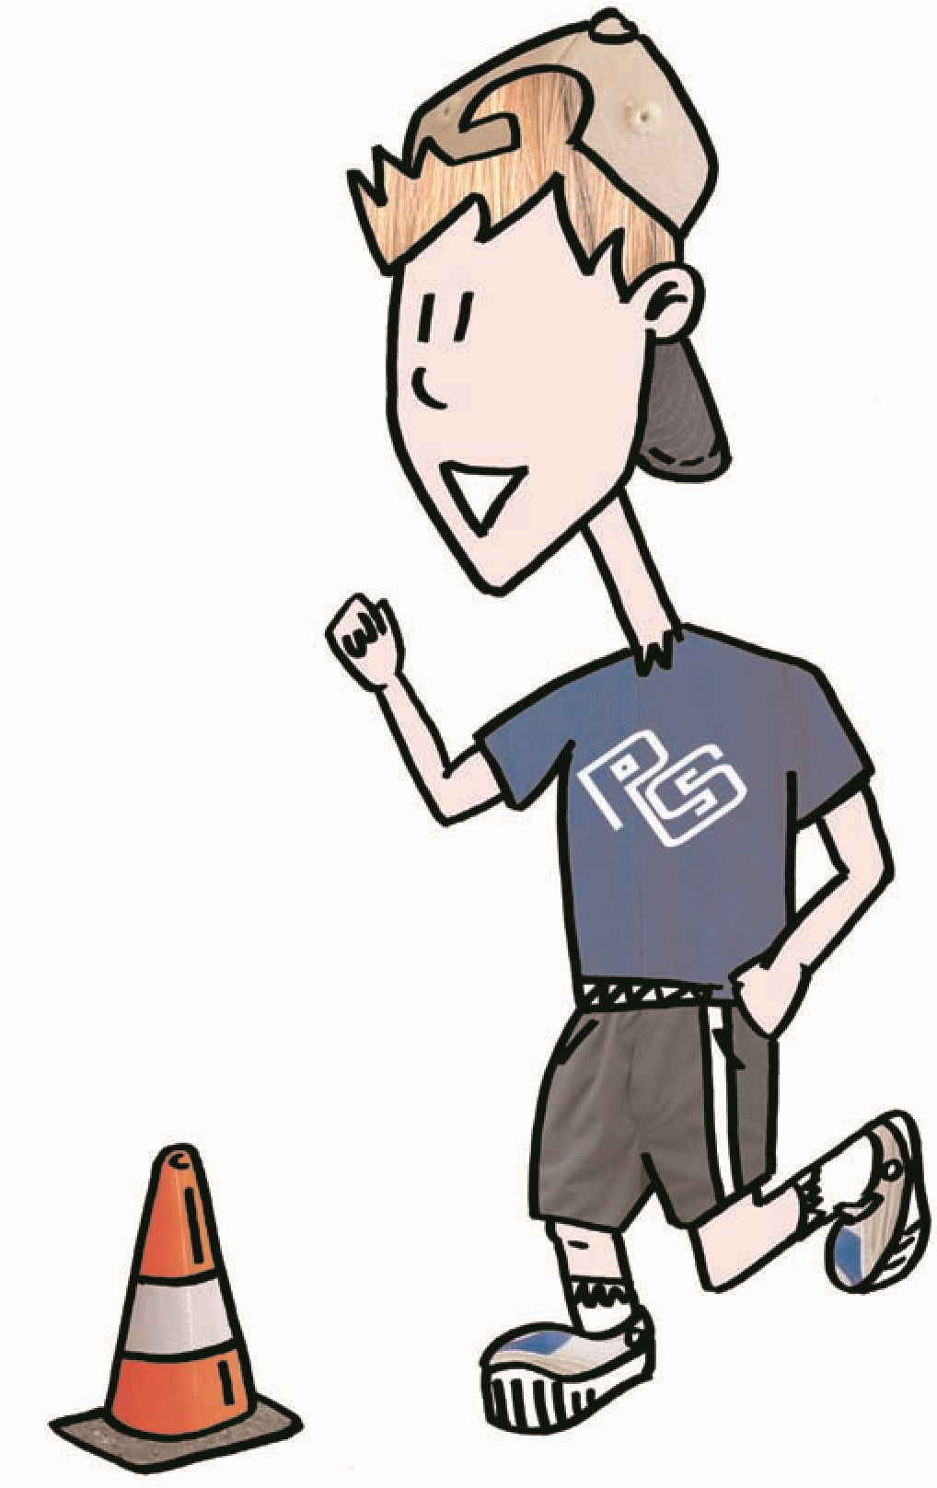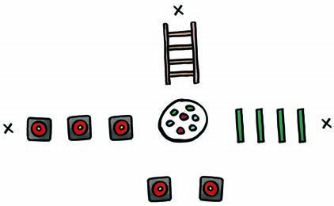
Challenge!
SPEED:
Speed is essential to all athletes, and
whatever sport you play, it will allow you to
react quicker than your opponent, recover
quicker and perform your skills with greater
intensity and control.
How fast can you carry the coloured beanbags
-
one at a time, and place them on the correct
spot, while tackling the different pieces of
equipment?
 |  | Record your time here:
Week 1 | Week 2 | Week 3 | Week 4 | Week 5 | Week 6
Station 2
 |  | Record your score here:
Week 1 |  | Week 2 |  | Week 3 |  | Week 4 |  | Week 5 |  | Week 6
L | R | L | R | L | R | L | R | L | R | L | R
The Agility Challenge! 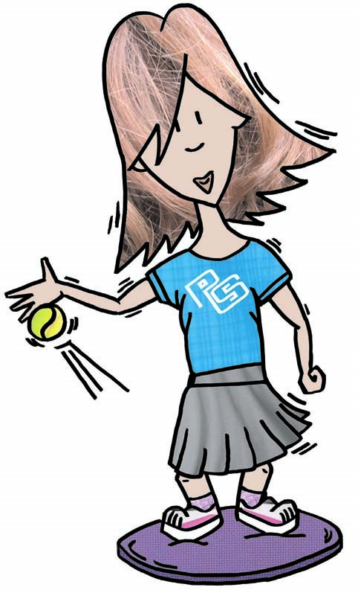
AGILITY:
Being agile and having good
body control will allow your
technique to better withstand
external pressure and react
efficiently to challenges.
How many catches can you make on the
agility disc in 30 seconds using your
right hand for 5 attempts and left hand
for 5 attempts?

Station 3
The Slalom Relay!
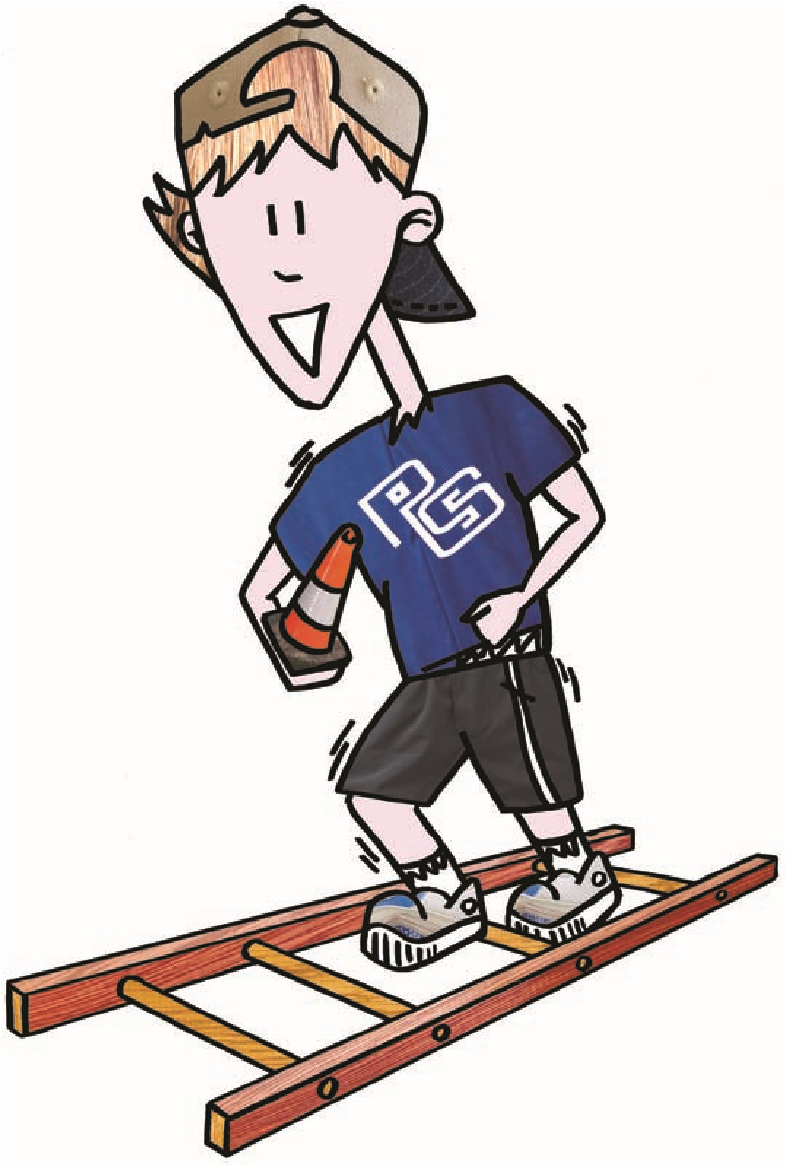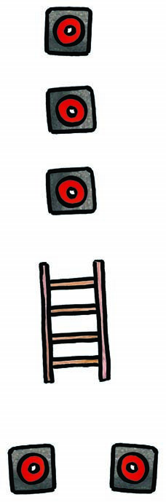
How quickly can you collect 10 cones
one at a time, while going through
the slalom
?
RANDOM
SPEED:
If you can change
direction with speed,
when you play sport
it will allow you to
get past opponents
with efficiency.
 |  | Record your time here:
Week 1 | Week 2 | Week 3 | Week 4 | Week 5 | Week 6
Station 4
Jump for it!
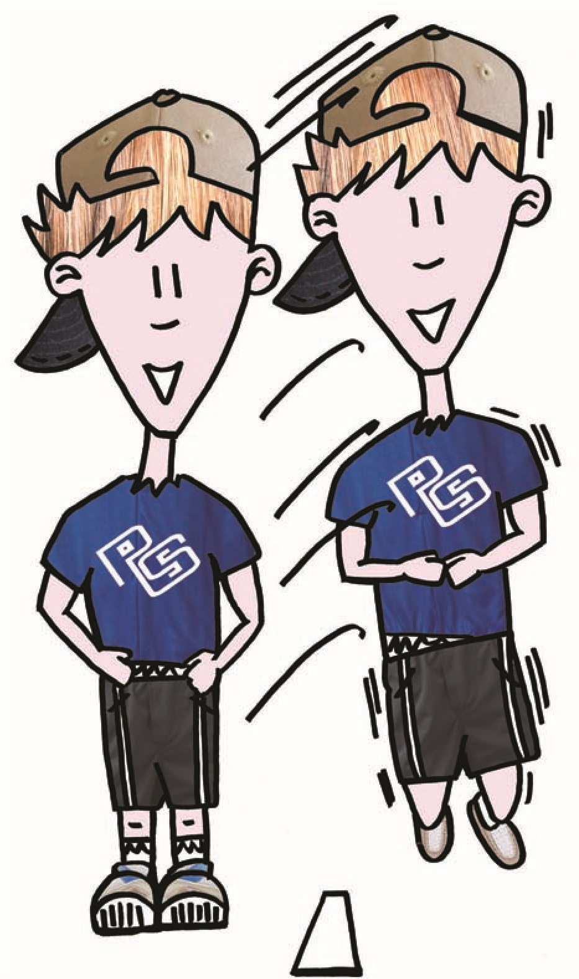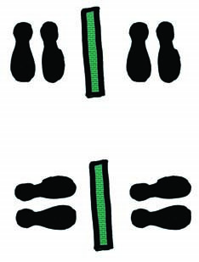
BALANCE:
Being able to control
your body while
moving or stationary
will assist you to be
successful at sport.
How many lateral and linear
jumps can you perform in
30
seconds?
 |  | Record your score here:
Week 1 |  | Week 2 |  | Week 3 |  | Week 4 |  | Week 5 |  | Week 6
Lateral | Linear | Lateral | Linear | Lateral | Linear | Lateral | Linear | Lateral | Linear | Lateral | Linear
Cooling Down!
When I have finished my circuit I understand the importance of cooling down.
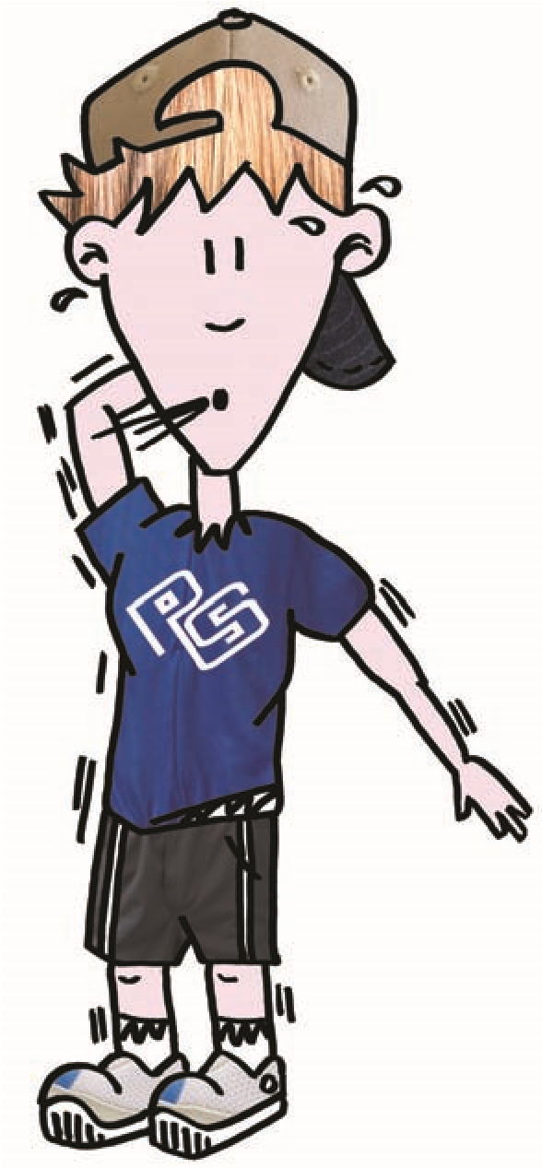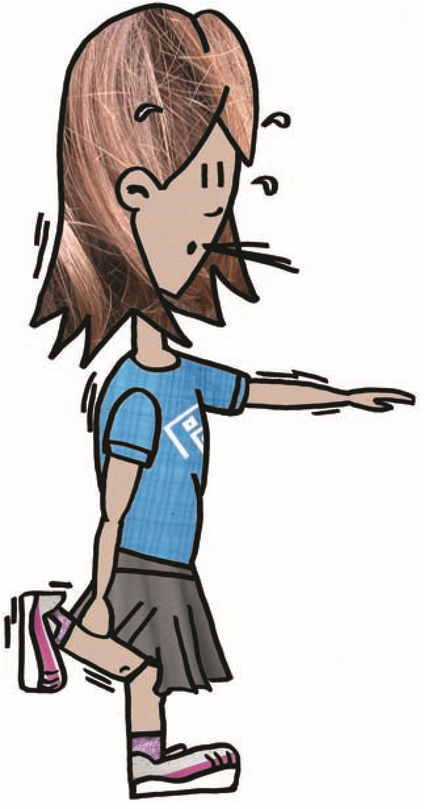
Put the missing words in the correct sentence:
Slower Recover Relaxed
If I cool – down it helps me to _____________ quicker.
A cool – down helps me to get my body back to a more _____________ state.
A cool-down should be done _____________ than a warm-up.
WELL DONE!
you have completed your circuit book!

