P.E lessons - Week 3 - Thursday 21st January
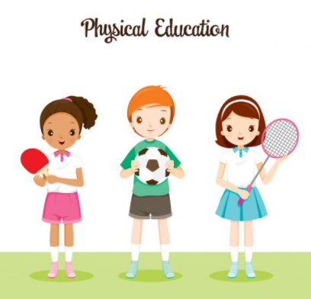

Enjoy taking part in some online PE lessons….

Remember to warm up first in a safe space and then…

Disney Shake up Games

Use the link https://www.nhs.uk/10-minute-shake-up/shake-ups?filter=zootropolis

Or search NHS ten-minute shake up games

And choose three new activities to try.

HIIT workout
https://www.youtube.com/watch?v=lc1Ag9m7XQo
If you are working from a paper pack at home, please type in the website address above exactly as you see it above.
Have fun!

