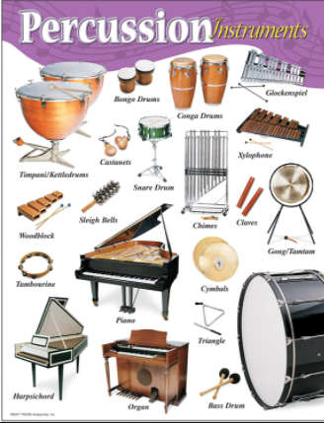
Music –Year 5 Week 3 Timbre –
Developing body percussion Part 1.

Use the link below to find your
third lesson all about percussion:

https://classroom.thenational.academy/lessons/developing-body-percussion-part-1-6rv3ar

Or search: Oak Academy KS2 music Developing body percussion Part 1.

Listen carefully and have fun!

