P.E lessons - Week 2 - Thursday 14th January
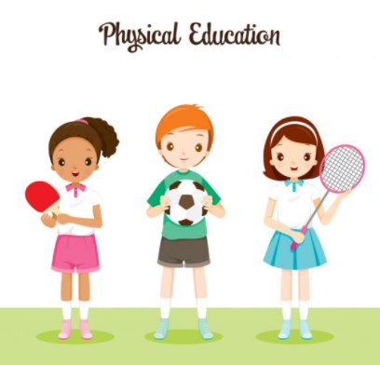

Enjoy taking part in some online PE lessons….

Remember to warm up first in a safe space and then…

Disney Shake up Games

Use the link https://www.nhs.uk/10-minute-shake-up/shake-ups?filter=zootropolis

Or search NHS ten-minute shake up games

And choose three activities to try.

YOGA
You can use the links below
https://www.youtube.com/watch?v=j_3weVPH0-U
or search YouTube for Cosmic Kids Wizard of Oz Yoga (An adult should help you to do this)

Have fun!

