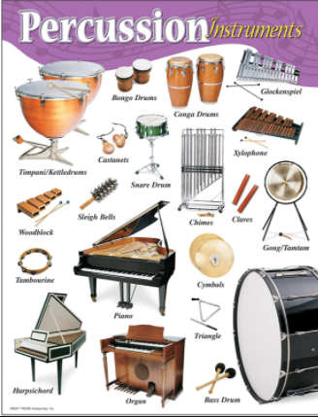
Music –Year 5 Week 1 Timbre – exploring
percussion

Use the link below to find your
first lesson all about percussion:

https://classroom.thenational.academy/lessons/exploring-percussion-chk66t

Or search: Oak academy ks2 music exploring percussion

Listen carefully and have fun!

