South America Map-Reading
Use the map to answer the questions about South America.
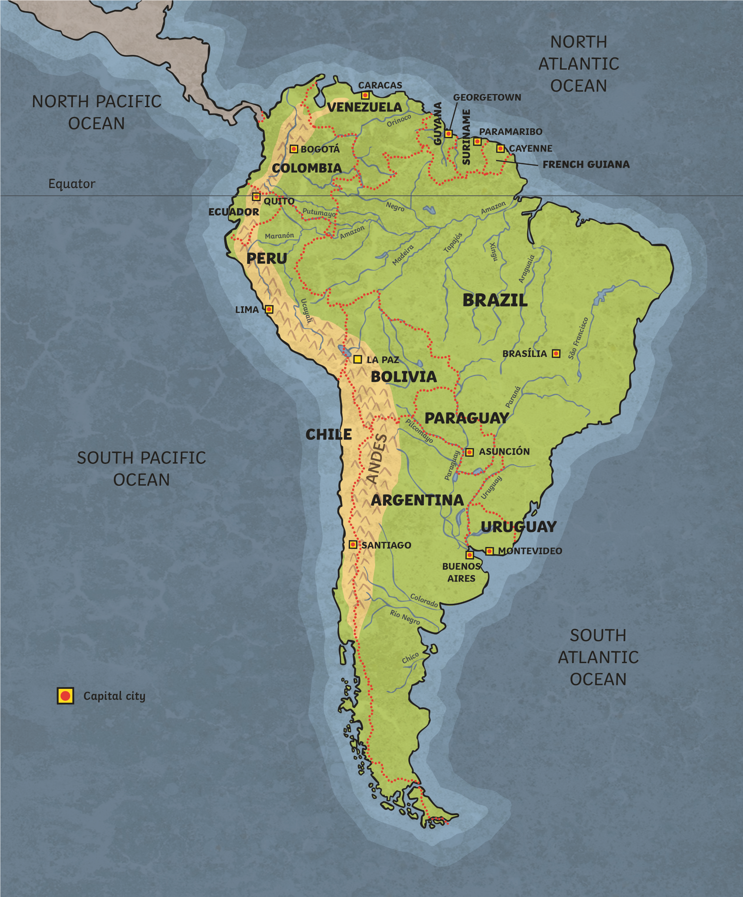
Lake Titicaca
Page 1 of 2

South America Map-Reading Questions
- Name the countries in South America.

- What is the capital city of Brazil?

- Name three rivers in Brazil.

- Which countries have the Andes Mountains running through them?

- Which countries in South America are on the equator?

- Name the capital city in Ecuador which is on the equator.

- Which oceans lie either side of South America?

- Which mountain lake lies on the border between Bolivia and Peru?

- Challenge! Create two questions of your own and ask a friend!

Page 2 of 2
Page 1 of 1

